|  |  |
| --- | --- |
| **USCIS Nonimmigrant Worker Petition Processing System**  **User Guide** |  |

1. Main Menu:

Upon accessing the system, users will encounter the main menu screen, featuring three primary buttons:

* Enter a New Request: Select this option to initiate the process of submitting a new request.
* Review Requests: Choose this option to review existing requests.
* Approve Requests: Select this option to manage approvals for submitted requests.

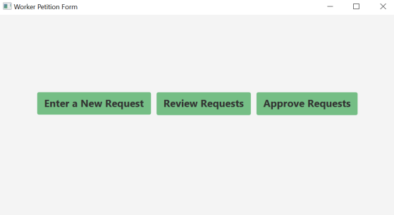

1. Entering a New Request:

* After selecting "Enter a New Request," the system will navigate to a new screen presenting two distinct categories:
  + Petition's Information
  + Beneficiary's Information
* Users are required to input all relevant data within these categories and then submit the form.
* Additionally, users have the option to return to the main menu if needed.

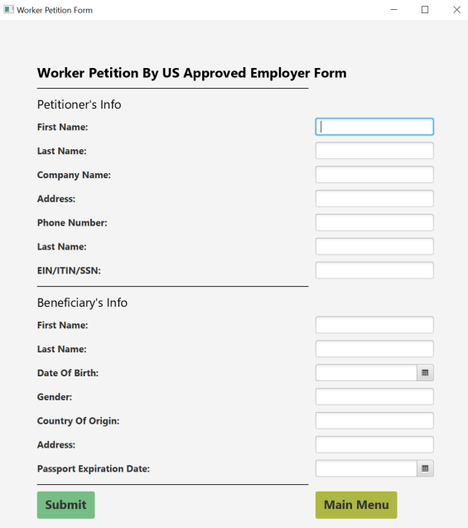

1. Reviewing Worker Petition:

* Upon selecting "Review Worker Petition," users will be presented with a screen displaying the previously entered form.
* Users are then prompted with options to either:
  + Confirm: Proceed with the existing information.
  + Edit Request: Modify the entered data as necessary.
* Users can also opt to return to the main menu from this screen.

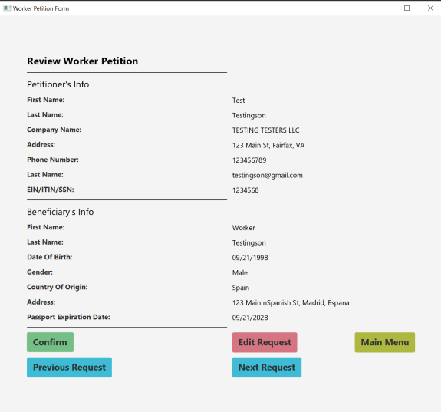

1. Approving Worker Petition:

* Once the supervisor approves the Worker Petition, they can review the information presented.
* The supervisor then has the authority to choose either:
  + Approve: Authorize the request.
  + Deny: Reject the request based on the provided information.

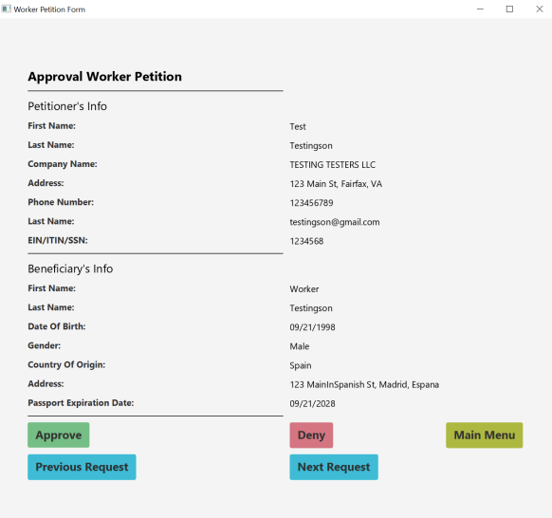

This user guide outlines the systematic process of utilizing the system, providing clear instructions for each step to ensure efficient navigation and utilization of functionalities.